Problem Solving – level 5

1. How many different three-digit numbers can be found using three of the digits 6, 7, 8, 9 only once in each number?

2. The Blue Boys scored 13 points in a rugby league match. In how many ways could they get this score?

Note: A conversion can only be attempted after each try is scored.

Try - 4 points
Goal (conversion) – 2 points
Field Goal - 1 point

3. Dominoes are divided in half. The number of dots on each part can be anything from 0 to 6. How many different dominoes are possible?

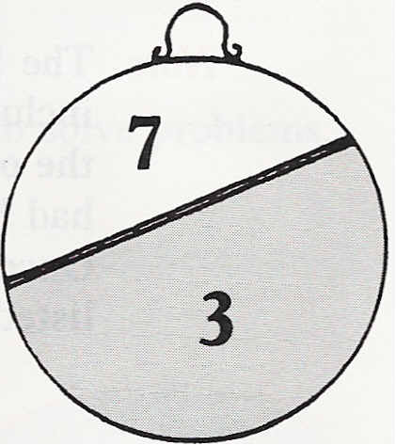
4. A dart thrown at this board scores either 3 or 7. Adrienne throws as many darts as she wishes and adds together all her scores. No matter how many darts she throws, there are some totals she will never be able to get.

Which totals are not possible?

5. The digit sum of the number 124 is 1 + 2 + 4 = 7.
How many numbers between 1 and 200 have a digit sum of 7?

6. Andrew's mother gave Andrew a problem to solve that she had been given when she was at school. It was: "In how many ways can you have coins that total exactly 18 pence? You may use just 1p, 2p, 5p and 10p coins but you may use as many of each as you like". Andrew worked out that there were 31 ways. Was he right?
7. There is a song which begins like this:

"On the first day of Christmas my true love sent to me
A partridge in a pear tree.
On the second day of Christmas my true love sent to me
Two turtle doves and a partridge in a pear tree.
On the third day of Christmas my true love sent to me
Three french hens, two turtle doves and a partridge in a pear tree. On the fourth. . ."

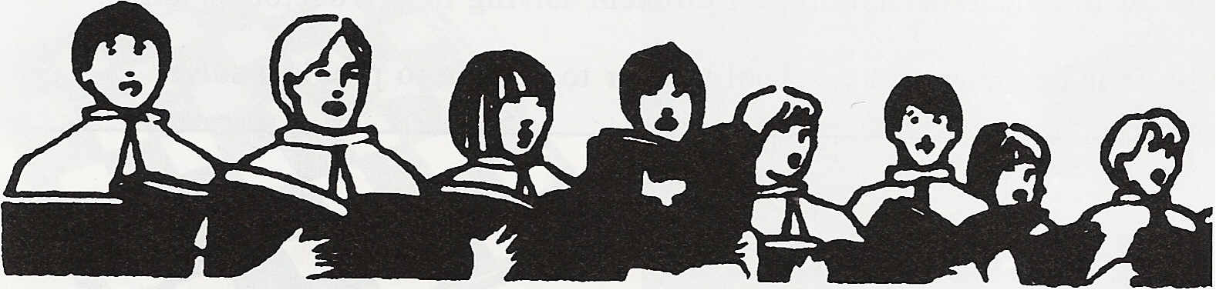
And finishes like this:

"On the twelfth day of Christmas my true love sent to me
12 drummers drumming, 11 pipers piping, 10 lords a-leaping, 9 ladies dancing, 8 maids a-milking, 7 swans a-swimming, 6 geese a-laying, 5 gold rings, 4 calling birds, 3 french hens, 2 turtle doves and a partridge in a pear tree".

After the twelve days, how many turtle doves had been sent?

8. Kash throws a die 10 times and adds together all 10 scores. The total is 34. If he throws each possible score (1, 2, 3, 4, 5 or 6) at least once, what numbers came up on his die?

Is there more than one answer?

9. Three darts are thrown at this unusual dart board.
What total scores are possible if all three darts hit the board?

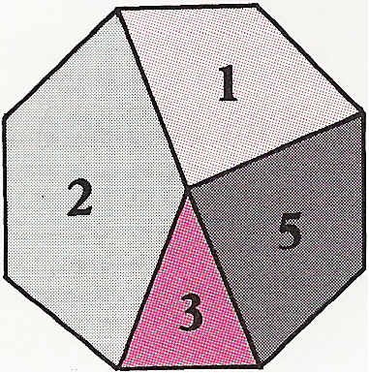

What if one or more darts miss the board?

